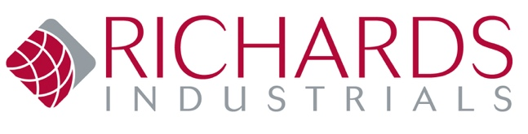
CUSTOMER FEEDBACK FORM
Receiving feedback from our customers, whether positive or constructive, plays an important role in the development of continuous improvement of our
quality management and customer service expectations. With this feedback form we seek to:
- Identify and address any instances of non-conformity of orders and/or products received by the customer.
- Identify and correct product and process deficiencies.
- Assess areas for product and process improvements when needed.

CUSTOMER INFORMATION:
COMPANY NAME | CONTACT NAME
ADDRESS | COUNTRY, CITY, STATE ZIP
PHONE | EMAIL
PRODUCT INFORMATION:
PRODUCT PART# RI ORDER# CUSTOMER PO#
FEEDBACK INFORMATION:
DATE OF ISSUE
DETAILS OF ISSUE OR DESCRIPTION:
ACTION REQUESTED: | YES OR NO?
ADDITIONAL COMMENTS: Form can be sent to Tina Bowen at tbowen@richardsind.com.
Richards Industrials is the parent company of Jordan Valve, Steriflow Valve, Steriflow Food & Beverage, LowFlow Valve, Hex Valve, Bestobell Steam Traps
and Marwin Valve.

